**Co5**

**1.write a program to read a file line by line and store it into a list.**

f1=open("file.txt","r")

print(f1.readline())

print(f1.readline())

print(f1.readline())

f1.seek(0,0)

print(f1.readlines())

print()

**file.txt**

hi

how are you

i am fine

**output:**

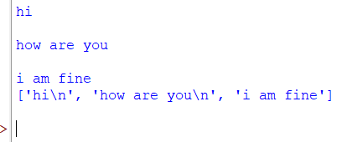

**2.Python program to copy odd lines of one file to other.**

fn = open('fil1.txt', 'r')

fn1 = open('fil2.txt', 'w')

cont = fn.readlines()

type(cont)

for i in range(0, len(cont)):

if(i%2!=0):

fn1.write(cont[i])

else:

pass

fn1.close()

fn1 = open('fil2.txt', 'r')

fn=open('fil1.txt','r')

cont1 = fn1.read()

print(cont1)

fn.close()

fn1.close()

**fil1.txt**

hi

how are you

i am fine

thank u

so much

**output:**

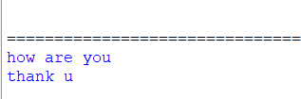

**3. Write a Python program to read each row from a given csv file and print a list of strings..**

import csv

filename = "username.csv"

rows = []

cf=open(filename, 'r')

csvreader = csv.reader(cf)

for r in csvreader:

rows.append(r)

print(rows)

cf.close()

**username.cvs**

|  |  |  |  |
| --- | --- | --- | --- |
| Username; Identifier;Firstname;Lastname | | | |
| booker12;9012;Rachel;Booker | | |  |
| grey07;2070;Laura;Grey | | |  |
| johnson81;4081;Craig;Johnson | | |  |
| jenkins46;9346;Mary;Jenkins | | |  |
| smith79;5079;Jamie;Smith | | |  |
|  |  |  |  |

**output:**



**4. Write a Python program to read specific columns of a given CSV file and print the content of the columns.**

import csv

filename = "emp.txt"

fields = []

rows = []

cf=open(filename, 'r')

csvreader = csv.DictReader(cf)

for r in csvreader:

print(dict(r))

**emp.txt**

name,department,birthday month

John Smith,Accounting,November

Erica Meyers,IT,March

**output:**

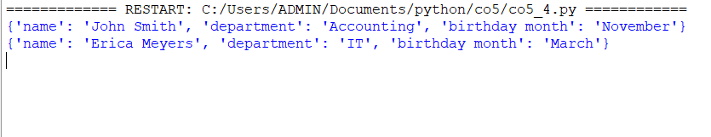

**5. Write a Python program to write a Python dictionary to a csv file. After writing the CSV file read the CSV file and display the content**.

import csv

field_names = ['No', 'Company', 'Car Model']

cars = [

{'No': 1, 'Company': 'Ferrari', 'Car Model': '488 GTB'},

{'No': 2, 'Company': 'Porsche', 'Car Model': '918 Spyder'},

{'No': 3, 'Company': 'Bugatti', 'Car Model': 'La Voiture Noire'},

{'No': 4, 'Company': 'Rolls Royce', 'Car Model': 'Phantom'},

{'No': 5, 'Company': 'BMW', 'Car Model': 'BMW X7'},

]

with open('Names1.csv', 'w') as csvfile:

writer = csv.DictWriter(csvfile, fieldnames = field_names)

writer.writeheader()

writer.writerows(cars)

#print(".................")

filename = "names1.csv"

cf=open(filename, 'r')

rows=[]

csvreader = csv.reader(cf)

for r in csvreader:

rows.append(r)

for r in rows[:3]:

print(*r)

**output:**

